Task 1
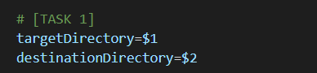
Task 2
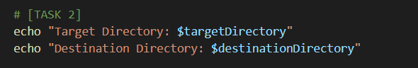
Task 3
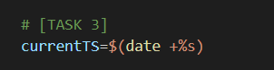
Task 4
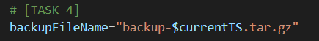
Task 5
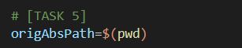
Task 6
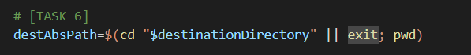
Task 7
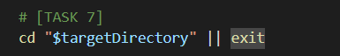
Task 8
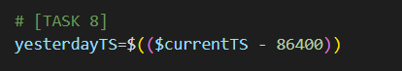
Task 9, 10 and 11
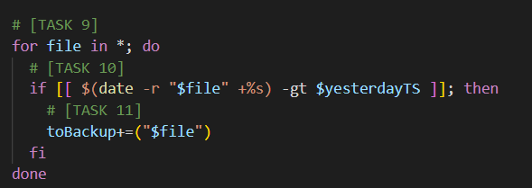
Task 12
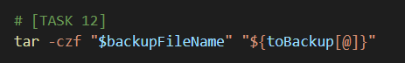
Task 13
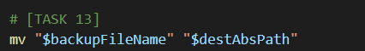
15-executable.jpeg or png.
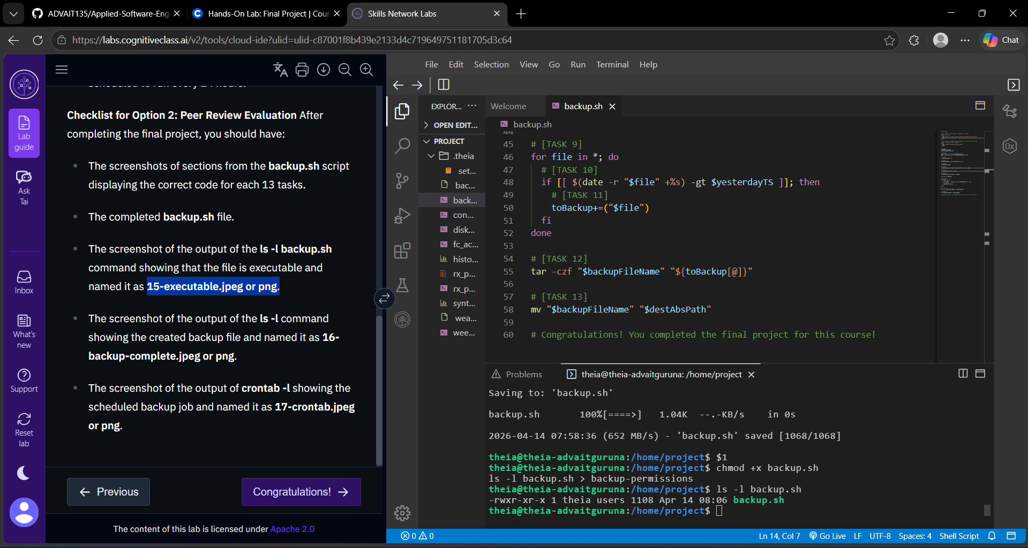

17-crontab.jpeg or png.

